**Overview**

**Survey Drones**

*Listening for*: survey_support, support_eta

*Can send*: alert_fire, survey_support, request_battery, request_maintenance, fire_out

**Maintenance Drones**

*Listening for*: request_battery, breakdown_calls

*Can send*: support_eta

**Firefighting Drones**

*Listening for:* fire_alert, backup_call(from another fire drone), support_eta

*Can send:* water_out_alert(asking for a substitution), need_backup, fire_out, request_battery, breakdown_alert, alert_humans

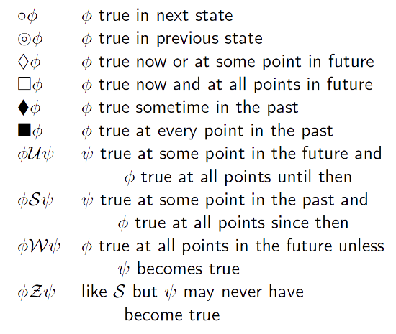

Temporal logic symbols

**Symbols:** ◯ ⌾ ◇ ⯁ ⬛ ⬜ ∀ ∃ ∄ ⌐ 𝓩 Ⲫ 𝓦 Ｓ U ψ →

**Survey Drones**

⌾ ask(survey_support) → action(move_in_requested_drone_area)

⌾ fact(fire_confirmed) → ◇ give(alert_fire)

⌾ fact(charging<50) → ◇ give(request_battery)

⌾ fact(breakdown) → ◇ give(request_maintenance) AND ◇ give(survey_support)

(fact(fire_fighting)Ｓ(fire_confirmed)) AND fact(fire_ceased) → give(fire_out)

**Maintenance Drones**

⌾ ask(request_battery) AND fact(available)→action(deliver_battery) AND fact(⌐available)

⌾ fact(request_completed) →fact(available)

⌾ ask(request_battery) AND fact(⌐available) → fact(wait) W fact(available)

⌾ ask(breakdown_call) AND fact(available)→ action(deliver_maintenance) AND fact(⌐available)

⌾ ask(breakdown_call) AND fact(⌐available)→ fact(wait) W fact(available)

⌾ fact(wait) AND fact(available) → action(deliver_battery) OR action(deliver_maintenance)

To be added later:

1. Prioritise the requests received from firefighters over survey
2. Prioritise the maintenance requests over battery request
3. Drone cannot handle battery_request and maintenance_requests at the same time unless both are coming from the same drone(done_id).

**Firefighter Drones**

*Legend: agent_name (listens_for) [asks_for]*

Df (fire_alert, backup_call, support_eta) [water_out_alert, need_backup, fire_out, request_battery, breakdown_alert, alert_humans]:

⌾ fire_alert → ◇ reach alert coordinates

⌾ backup_call → ◇ reach backup coordinates

⌾ fact(charging<50) → ◇ give(request_battery)

⌾ fact(water_out) → ◇ give(water_out_alert) AND ◇ give(need_backup)

⌾ fact(breakdown) → ◇ give(request_maintenance) AND ◇ give(need_backup)

⌾ fact(code_red)→ ◇ give(alert_humans)

(fire_alert U fact(fire_ceased)) → ◇ give(fire_out)